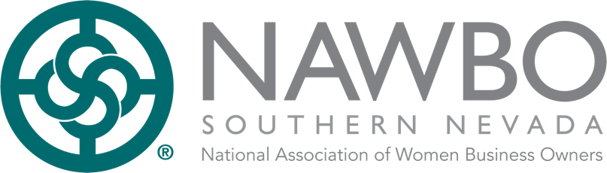
Request for Proposal – Swag Bags

Purpose of Proposal

The National Association of Women Business Owners (NAWBO) Southern Nevada Chapter gathers each year to recognize women and organizations in our community when we host the Women of Distinction Awards. NAWBO Southern Nevada has hosted the Women of Distinction Awards since 1998 to celebrate the accomplishments of women. The program highlights women whose excellence and dedication sets them apart in their fields and inspires success. We commemorate the achievements of all our nominees at this event.
Women are recognized in the following categories: Rising Star, Glass Ceiling, Entrepreneur of the Year, Arts/Entertainment/Media, Business/Retail/Manufacturing, Corporate/Government Services, Education, Gaming/Hospitality/Convention Services, Medical/Healthcare Services, Philanthropy/Community Service, Professional Services and Real Estate/Construction.

We are seeking swag bags to give to all the attendees of this year’s awards at the October 26, 2021, luncheon at Paris Las Vegas Versailles Ballroom.

Company Name: | Click here to enter text. | Date: | Click here to enter text.

Address: | Click here to enter text.

City: | Click here to enter text. | State: | Click here to enter text. | Zip Code: | Click here to enter text.

Phone: | Click here to enter text. | Email: | Click here to enter text.

Woman Owned: | Click here to enter text. | Minority Owned: | Click here to enter text. | Veteran Owned: | Click here to enter text.

Why should NAWBO select your company

Click here to enter text.

Sample Images

References

Please list three professional references.
Reference 1:
Full Name: | Click here to enter text. | Relationship: | Click here to enter text.
Company: | Click here to enter text. | Phone: | Click here to enter text.
Address: | Click here to enter text.
Reference 2:
Full Name: | Click here to enter text. | Relationship: | Click here to enter text.
Company: | Click here to enter text. | Phone: | Click here to enter text.
Address: | Click here to enter text.
Reference 3:
Full Name: | Click here to enter text. | Relationship: | Click here to enter text.
Company: | Click here to enter text. | Phone: | Click here to enter text.
Address: | Click here to enter text.
Proposed Costs

Per Item Cost: |  | Click here to enter text. | Set Up: Fees: |  | Click here to enter text.
Payment Requirements Deposit and Terms: |  | Click here to enter text.

Timeline of RFP

- 6/30/21: RFP Date Release  - 7/9/21: RFP Questions Due  - 7/30/21: RFP Submittal Date  - 7/30/21: Sample and Proof Approval Dates  - 8/23/21: RFP Award Date  - 9/1/21: Contract Execution Date | - 9/1/21: NDA Execution Date  - 9/15/21: Deposit Date  - 9/27/21: Final Proof of Swag Bag  - 10/15/21: Bags delivered to NAWBO
Intellectual Property Rights

To the extent permitted by law, all works created by the successful vendor(s) under this RFP shall be the exclusive property of NAWBO and shall be deemed “work made for hire” under the United States Copyright Act. The successful vendor(s) agrees to execute any documents reasonably required by NAWBO to evidence NAWBO’s exclusive ownership of the work products, and all intellectual property rights therein.
Photographers will coordinate with NAWBO to ensure permissions of subjects.
Business License
You must submit a copy of your current business license with the RFP.
Insurance
Awarded company must submit a copy of the company’s insurance coverage for liability and worker’s compensation. If company is owner operated and does not have insurance, no worker’s compensation is required, but liability coverage is still required.

I certify that my answers are true and complete to the best of my knowledge.
If this application leads to employment, I understand that false or misleading information in my application or interview may result in my release.

Signature: |  | Date: | Click here to enter text.

Please submit this RFP and all required documents and samples (if applicable) to WODA@NAWBOSNV.org.

